INNOVENTIONS Brain Resource Development Institute
Innovation + Invention
ExNoRa Founder’s Resume
Name | Dr M.B.NIRMAL
Designation | FOUNDER,
Organisation | ExNoRa Innovators International
Past | Chief Manager, Indian Overseas Bank, Hong Kong (VRS)
Qualification | B.Com., B.L., CAIIB. & Hony. Doctorale presented by Dr G. Madhavan Nair, Chairman. ISRO for Sathyabhama University
Phone & Mobile | 044-2363 88 77 +91 98400 34900
Email | mbnirmal@gmail.com exnora@gmail.com
Website | www.7thsense.guru www.exnorainnovators.club
Social Media | FB Twitter

Mr.M.B.NIRMAL is a globally known Motivator, Innovator, Change-Maker, Author-writer, Mind Programmer, Humorist, Orator, Trainer, Environmentalist, Social Reformer and a Social-Activist. Mr Nirmal was an executive with the Indian Overseas Bank, DIRECTOR- Coffee Board and an EXPERT ADVISER to the Ministry of Environment & Forests, Govt of India.& LIC Southern Zone

He is also Rtn Nirmal, a Paul Harris Fellow, now Honorary Member of Rotary Club of Midtown and was Past President of Rotary Club of Madras North and Past District Chairman of Rotary District 3230. RONORTH 9 MEGA EVENTS were proposed and carried out by him.

With an aim to realize a cleaner, greener and a more enviro-friendly world M.B.Nirmal founded the ExNoRa International a Non-Profit, Non-Political, Secular, Non-Governmental, Environmental Service Organisation in 1989, by mobilizing and empowering local communities to participate in preserving nature and preventing environmental degradation so as to improve the quality of life of the common man. Now after 28 years of its existence it has grown into a wide spread movement covering many parts of India and several countries abroad.

With an aim to conduct individual and corporate training programs that are professional, clean, inspiring, engaging and filled with solid content in order to unlock the mental locks and overcome the mental blocks he founded the INNOVENTIONS (Innovations + Inventions) the Brain Resource development Institute about two decades ago. His training programs are motivating, entertaining and educational delivering excellent results. He has successfully conducted training workshops in Hong Kong, Malaysia, Singapore, Sri Lanka and USA besides several Indian cities.

With an aim to encourage, enable and empower every citizen of India to eliminate corruption at all levels of the society he founded the 5th PILLAR.

With an aim to bring about a revolution in communal harmony, to cure the illness of the society, to have a Common Vision & Mission to tackle the enemies of humankind and collectively wage a war against them he founded ‘Maa’ ( 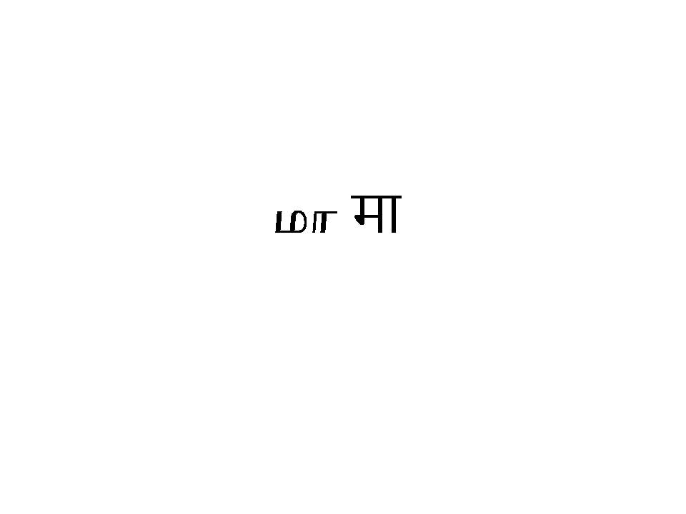/) for motherliness.

RECOGNITIONS :

“Innovator for Public” from ASHOKA, USA- (recognition with cash Award)

INDIA TODAY in its Cover Story stated, “Mr. M B Nirmal is one of the ten Angels of Change transforming India”.

INDIAN EXPRESS, described him as “One of the six Crusaders who will change India”.

READER’S DIGEST, proclaimed him as a ‘Hero For Today’ and wrote ‘Nirmal is a peerless leader who has a remarkable ability to inspire people to work together” (for Readers’ Digest).

THE INNER WHEEL CLUB - ROTARY INTERNATIONAL, - honoured him as “One of the six Pathfinders of India along with Mother Teresa”.

The CII / TAMILNADU have honoured him as One of the 100 most successful entrepreneurs of Tamilnadu who were responsible for its growth in its 60 years dream journey since independence.

He is member of CII Tamil Nadu Infrastructure Panel as well as CII GreenCo Committee.

He is serving a Social Scientist in LC-SCR of LifeCell International (P) Ltd., Chennai.

He was conferred Honorary Doctorate by Sathyabhama University which was handed over by Dr G. Madhavan Nair, Chief of ISRO

Outstanding Entrepreneur Award for TiECon 2009. Mr Nirmal received it along with India Cements & CSK N Srinivasan. SUN TV Kalanidhi Maran, Murugappa Group Chief Mr M V Subbiah, Mr Ravi Appaswami of Appaswami Builders, Mr P N Vasudevan of Equitas & Mr Sathish Babu of UniverCell.

He won four times the Best Manager of IOB Award with the RBI Governor (1987) and the then Finance Minister Mr. V P Singh 1988) This was followed by a Life Time Achievement of being recognised as the Excellent Bank Manager of the Nation among the managers of all the Nationalised Banks of the country.

“He has the ability to bring out the Gandhi in everyone” (South China Morning Post , Hong Kong).

“Wonder-Man of the Banking Industry” (for Malayala Manorama).

New India Times (USA) wrote”Mr. Nirmal’s speech at FETNA conference, Missouri, USA was electrifying. Many call him a Visionary, most regard him a motivator. He proved that motivation can move mountains and people too. He is always pregnant with ideas. The one thousand plus audience and participants stayed glued to their seats during his 90 minutes talk to get up only at the end to give him a standing ovation”.

Change Makers (Rotary News recognised Dr. M S Swaminathan for Green Revolution, Dr Verghese Kurien for White Revolution , M B Nirmal for Clean Revolution) .

“Catalyst of Social Change” “Nirmal’s Optimism is infectious” (The Hindu).

M B Nirmal was an editorial subject in seven leading newspapers / periodicals including.

Bhavan’s Journal (Written by Bharat Ratna Mr. C Subramaniam who referring to Nirmal said “There is still hope for India”) & in Times of India by Mr. Gurucharandas.

The Ministry of Finance of Government of India issued a circular to Chairman of all the Nationalised Banks to emulate Nirmal’s “Relationship Banking” as well as “Serve & Sell Banking” in their respective Banks.

M B Nirmal is a subject matter for 10th standard students in their school text book. ExNoRa founded by him is already a subject under part 4 of the University Curriculum.

Those who were recognised by Nirmal, on behalf of ExNoRa International : were the then Chief Minister Late Dr J Jayalalitha, then Chief Minister Dr Kalainger,Thiru M K Stalin and Australian Premier

He is Guru & Mentor for hundreds of YOUTH. Nirmal has also reprogrammed the minds of several convicts & top hardcore offenders and made them lead a life of honesty and non-violence.
For MORE INFORMATION on M B NIRMAL, please visit
www.homeexnora.org / www.7thsense.guru
- He is presently
- Expert Advisor of two top Advisory Committees of Government of Tamil Nadu,
- Solid Waste Management &
- Plastic Pollution Prevention

- Member Advisory Committee appointed by Madras High Court for abolition of Manual Scavenging

- Founder Trustee of EDIT TRUST of EQUITAS BANK with Mr P N Vasudevan & C K Gariyali

- Social Scientist in LifeCell International’s Institutional Committee for Stem Cell Research (LIC-SCR)

- Patron of Udhavi Karam , the Tamil Nadu State Association for the Welfare of Differently Abled

- Founder Adviser of Darshini Trust which reads and writes exams for the BLIND
Students (about 1500 were so far benefited to get their degrees, post graduate degrees & Ph.D.

- He is the FOUNDER of Human Diamond , an organisation for Reformation of Society’s dropouts. Nearly 100 were reformed .

- He is the Founder of Agni Stree an organisation for protection of women and children and Women Empowerment and Development

- He is the Founder of Vintage & Classic Car Owners Association

- Enlightenment : JEEVAN SHASTRA for Living as Human Being and Manushya Shastra for Being Human Being with Principled Simplicity and Voluntary Sacrifice

- He has spoken in most of the Tamil & Indian English TV Channels . Now he speaks for 10 minutes since 2016 March every day in PEPPERS TV 7.30 am on the topic Sambavangal Sollum Sangathigal & 7th Sense

- He is the Author of nine books in English & three in Tamil

- Fine Arts : He is the Cofounder of Hamsadwani one of the largest Carnatic Music Sabhas and VKR Cultural Academy for promoting and staging Dance & Theater
- Founder Chairman Parama Shanthi Nilayam involved clean & green burial grounds / crematoria
FAMILY
- His wife Dr Vijayalakshmi Nirmal MD, former Director, Madras Medical College and now is a Professor KIMS .
- His daughter Anita Nirmal Almeida and son-in-law Timothy Almeida , Son Manoj Nirmal and daughter-in-law Madhu Manoj are CITIZENS of USA and are software professionals.
- His father M S Basu was a veteran journalist , Editor of leading magazines of 1940s , 1950s & 1960s Kalai (Film Monthly) , Basarasu (Tamil Literary Monthly) , Kadambari (Weekly ) and was Associate Editor & Photo Editor of Pesum Padam (leading film magazine) . His mother Mts Saraswathi Basu was the first woman Editor in the Tamil World of a magazine Kalai way back in 1943 . His parents were instrumental in the introduction over 50 film artistes in the Film World including Jayalalitha, K R Vijaya, Balaji etc and promoter of many Artistes including Sivaji Ganesan . They were close family friends of MGR & Janaki Ramachandran SIBLINGS : Sisters Sowdamini Anandakrishnan, Latha Ravanan, Jayanthi Vedanayagam
MORE ON HIM & in & as PICTURES : http://www.homeexnora.org/founder.html & www.7thsense.guru

